|  |
| --- |

### **LinkedIn [ Key Sections Guidelines ]**

With more than 500 million registered users, and two new members joining every second, LinkedIn is the world's largest professional social media network and a powerful tool in a candidate's job hunting arsenal.

LinkedIn profiles are widely accepted as “virtual business cards” that also help users easily share information about their work history, education, and professional interests. For Job hunting, LinkedIn is considered one the most effective channels to showcase your work and reach out to recruiters.

(Make sure before doing any change in LinkedIn profile, you turn off sharing profile updates with your networks)

Your profile>Settings & Privacy>visibility>Visibility of your LinkedIn activity>Share Update profile updates with your network (Turn it off)

Key Sections in LinkedIn profile -

* Profile & Cover Photo
  + Profile Photo - Your profile picture on LinkedIn defines the authenticity of the profile. It must be added so that person visiting your profile considers your profile genuine.
    - Make sure photo quality is high quality and high resolution
    - Emphasizes your face (by having a solid color or blurred background)
    - Showcase your awesome smile.
    - The photograph should be in a decent professional attire.
    - The person should be facing the camera. (Direct eye contact)
    - Full face should be visible. (No side profiles)
    - The photograph should be in a standard portrait mode.
    - The photograph should have a plain and contrasting background colour.
    - The quality of the photograph should be HD.
    - The photograph should cover your waistline.
    - The photograph should be in standard JPEG/PNG format.
    - Below are two sample images for your reference.

Sample Profile Photos -

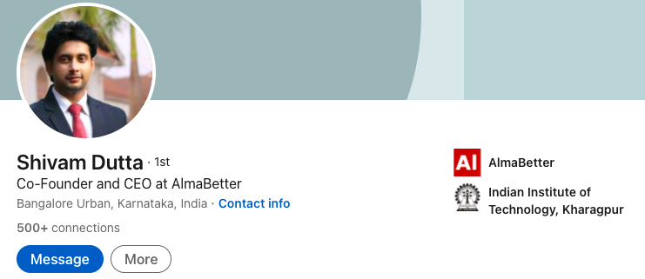

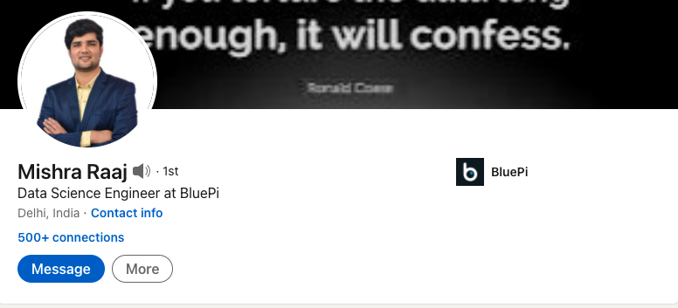

* + Cover Photo - Your cover photo is a fantastic place to show off some of your personality and accomplishments. It’s larger than your profile picture too so it’s likely going to grab more eyeballs and help you tell your story. It should be something you’re passionate about or use your cover photo as real estate to sell yourself. Few topics you can add
    - Presenting/speaking at any event.
    - Quotes related to your passion.
    - Doing volunteer work.
    - Taking part in a hobby like a marathon running, painting, hiking, teaching, etc.

Sample Profiles with Cover Photo -

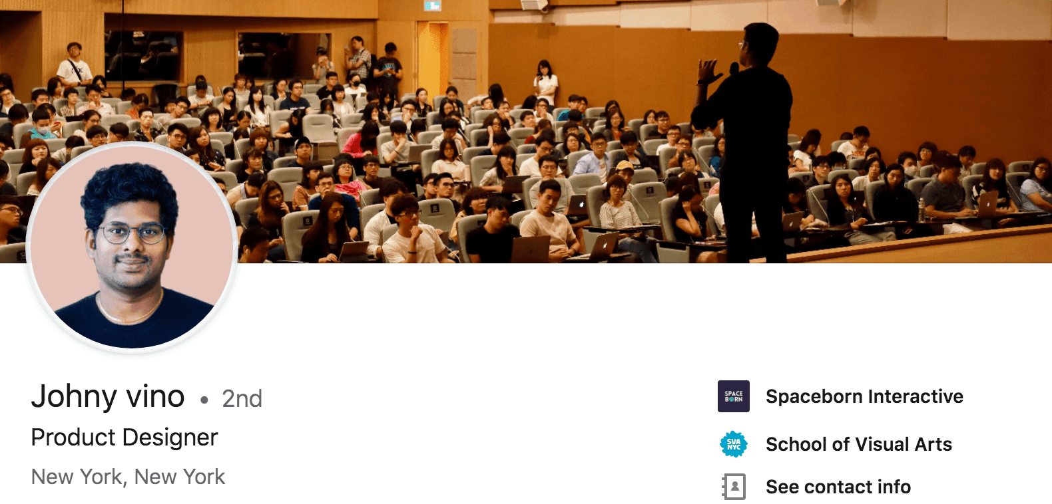

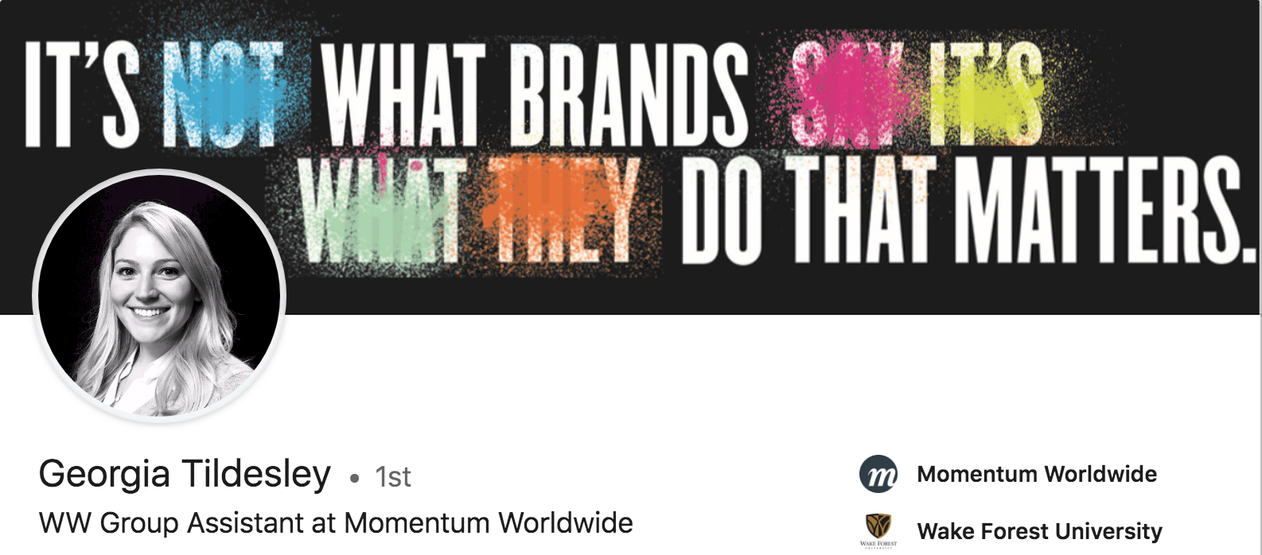

* Intro
  + Name - Your name should be in this format “Georgia Tildesley”; first alphabet of both first name and last name must be in capital.
  + Headline - Headlines definitely carry a lot of weight when it comes to being found in search results. Be very precise about what you are mentioning here. Take these as examples and add words that you feel relevant to your profile and optimize your LinkedIn headline to get more profile views.
    - Aspiring Data Scientist | NLP | Time Series | Python, Tableau & SQL Expert | Storyteller | Blogger
    - Aspiring Data Scientist | Deep Learning| NLP | Computer Vision | Scalable ML | Storyteller | Blogger

* About
  + Remember your LinkedIn ‘About’ section is for selling, not summarizing.
  + Sample -
    - I have demonstrated sound business judgment, well-developed planning, analytical, and communication skills, and a consistently high level of performance in a variety of progressively responsible and challenging roles. I am accustomed to a fast-paced environment where deadlines are a priority and can handle multiple jobs simultaneously. I have a keen interest in analytics, machine learning, sentiment analysis, and data processing. I have a strong desire to learn and seek out new relevant technologies.
* Featured
  + Share your existing medium blogs on Linkedin and make sure you feature them on your profile. At least 5 blogs must be featured.
  + In case you don’t have sufficient blogs written, you can post your EDA Capstone Project, also search Notebooks on Kaggle, pick any interesting notebook, explain it in your own words and post it on medium.
* Background
  + Work Experience -
    - Add **AlmaBetter** in the Company name.
    - In the title add capstone projects which you have added to your resume.
    - Add resume points in the description and upload your technical documentation for the project.
    - In the title also add Data Science trainee.
    - It should look like this -

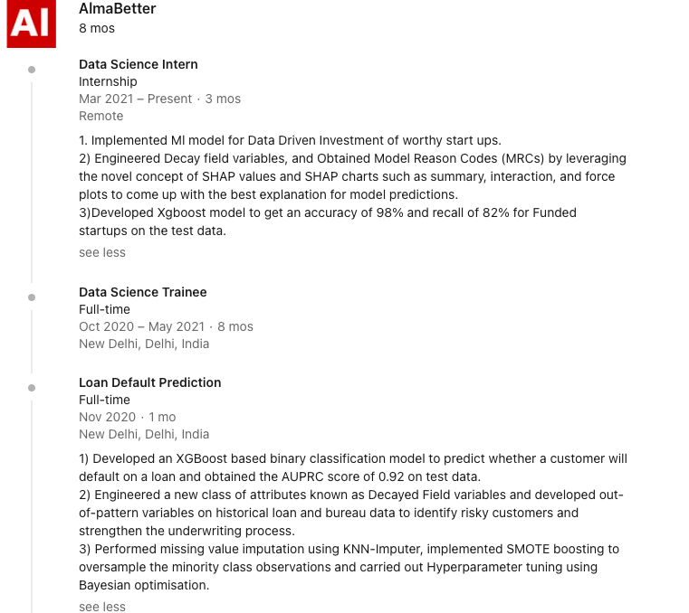

* Add other work experiences, internships or positions of responsibilities taken during college which you have added to your resume in a similar fashion.
  + Education - Add all your education and add relevant activities and descriptions for all. Including all your education details will help your profile to reach people of your school/ college.
  + Licenses & Certifications - Include all module certificates provided by AlmaBetter, other platforms, college & high school. You can also Include AlmaBetter Competency Challenge Certificates.
  + Volunteer experience - Add NSS, NSO, or any volunteer work done at any stage of your life.
* Skills
  + Adding skills is very important as this plays a key role in the LinkedIn search engine. Add relevant skills to your competency. You can pick skills that you have mentioned in your resume.
  + Sample skills - Data Analysis, Data Modelling, Python, SQL, Tableau, Power BI, MS Excel, Natural Language Processing, Deep Learning, Business Analytics, Text Mining, Sentiment Analysis, Machine Learning, Deep Learning, Azure, AWS, Predictive Analytics. (You can add skills relevant to your profile)
  + Note - Skill Endorsements give weightage to your skill, connect with AlmaBetter students in the cohort, friends, whoever you know on LinkedIn and get your skills endorsed.
* Accomplishments
  + Courses
    - Add relevant data science courses you have done with AlmaBetter.
    - Courses you can add to your profile -
      * Data Science using Python
      * Machine Learning using Python
      * Time Series Modeling
      * Probability & Statistics
      * Introduction to Natural Language Processing
      * SQL Fundamentals
      * Python Fundamentals
      * Data Visualization using Python
      * Advanced Mathematics for Machine Learning
      * Analytics Framework for Business Analytics
      * Convolution Neural Networks
      * Recurrent Neural Networks
      * ML & Data Engineering
  + Projects
    - Add your capstone project in this section with resume points.
    - You can also add projects which are not mentioned in your resume (EDA projects)
    - Add Creators - You must add your project mentor and team members as creators in the project section. In case the project was done without a mentor then only add other team members.
  + Honors & Awards
    - Add all the awards you have got till now.
  + Test Scores
    - Add all AlmaBetter Competency Challenge scores.
* Additional Information (Most Imp)
  + Request a Recommendation - You must get at least 2 recommendations for your profile. This will help your profile ranking in social media search engines. 1 recommendation will be from your career coach and 1 from your Almabetter mentors with whom you are close.
  + Sample LinkedIn Recommendations - [Link](https://docs.google.com/document/d/18gCQeCdqvWvyN2V5hIG9BPuVkChfndnEgDEdPhTyJnQ/edit) , Share this doc link with who you are reaching out for recommendations. It will help them to curate recommendations for you in a better way.
* Edit Public Profile & URL - You can edit the public profile link by clicking Edit public profile & URL on the right rail, and then clicking Edit URL. Ideally, you want to use some combination of your full name.
  + The right format for your profile link - linkedin.com/in/your-name
  + You can add some numbers at the end of the link that is already taken. linkedin.com/in/your-name01.

### **LinkedIn [ Tips & Tricks ]**

* **Make connections:** The faster you build your LinkedIn network, the faster you’ll find new opportunities. Start connecting with everyone you know. In addition to friends, classmates, and colleagues, connect with professors, family friends, old neighbors, and friends of friends. You can make things easier by changing LinkedIn’s standard, “I’d like to add you to my professional network on LinkedIn” to a personalized message. Try mentioning where you know the person, something you have in common, or even a fun fact. Additionally, it’s totally fine to connect with people you don't really know, as long as you have a good reason. If you’re a student, alumni are an excellent resource. Just let them know that you’re currently attending their school, were impressed with their career path, and would love some advice. Instant connection!
* **Let recruiters know you’re open for Jobs**
* **Be active on LinkedIn -** Share your own posts and also comment, like & share other posts relevant to your profile.
* **Give LinkedIn skill tests and flaunt on your profile. You will find this in the jobs section.**
* **Set Job alerts for profiles you are looking for. You will find this in the jobs section.**
* **Join Data Science related groups and like & share posts relevant to your profile.**
* **Actively participate in AlmaBetter Personal Branding Activity.**